Rick and Morty

Portal Protectors (WIP)

With Ember entertainment

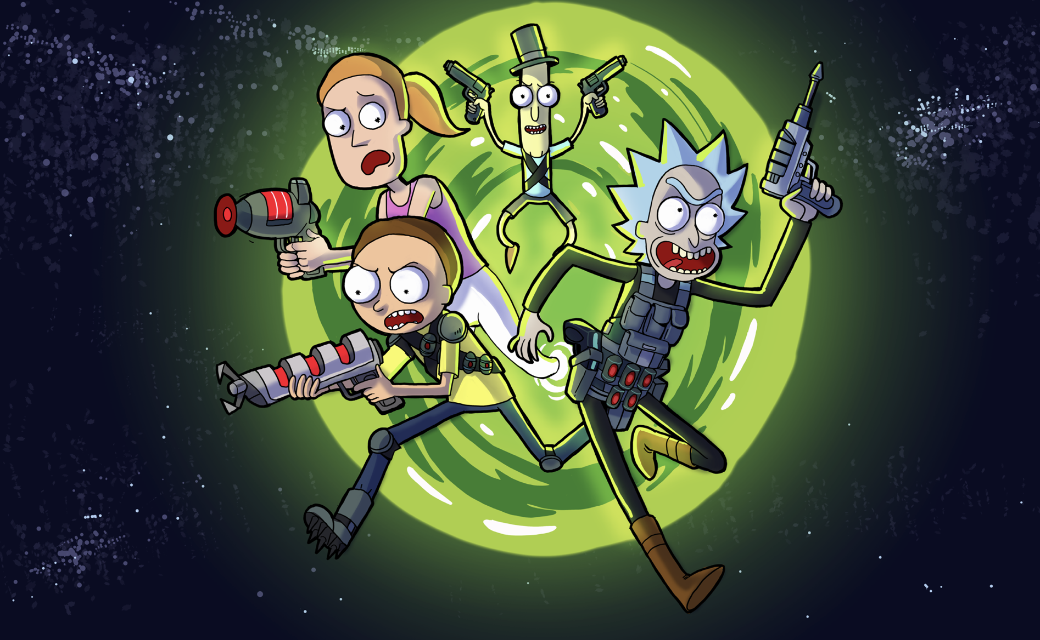

The Game Loop

1. Battle – The Gameplay
2. Collecting Loot – The Rewards
3. Crafting – Power Up!
4. Customize – Show me what you got!
5. PVP – Social Gameplay
6. Rickest Rick - Leaderboards
7. Council of Ricks – Alliance and Guild System
8. Monetization Overview
9. Development Requirements

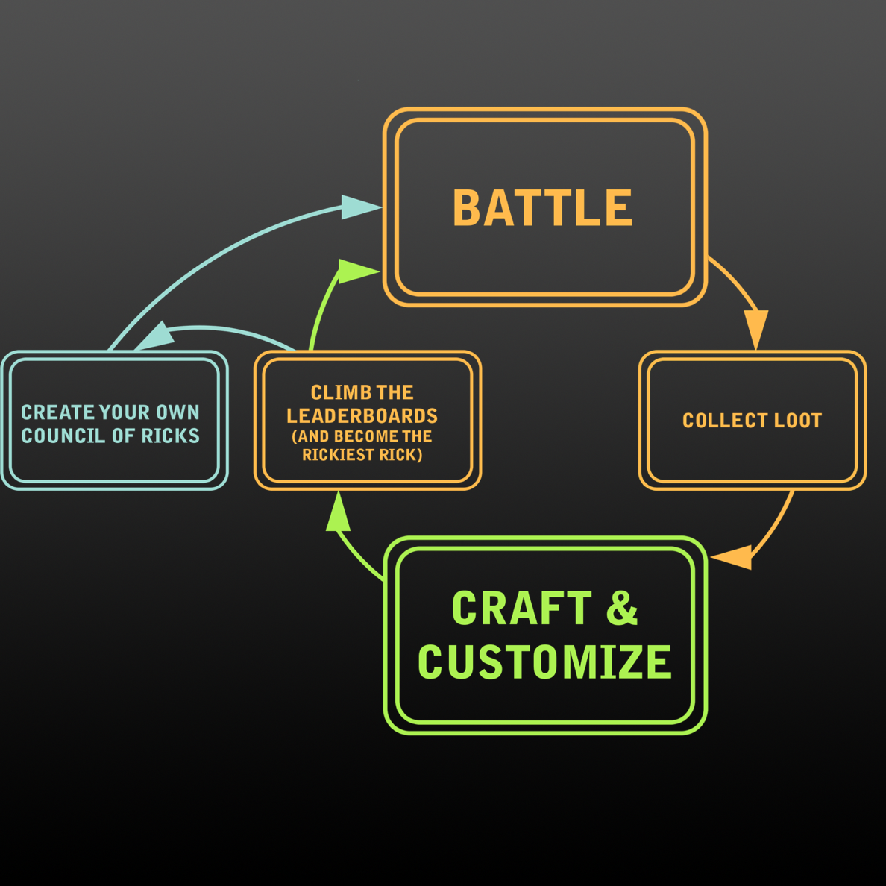

# 1: BATTLE - Battling with your Rick

Take your Rick and Morty to fight off hordes of enemies in an arcade style shooter. The gameplay will move fast and be exciting with a lot of visual explosions, deaths and power ups to create a fun exciting experience.

Gameplay Screen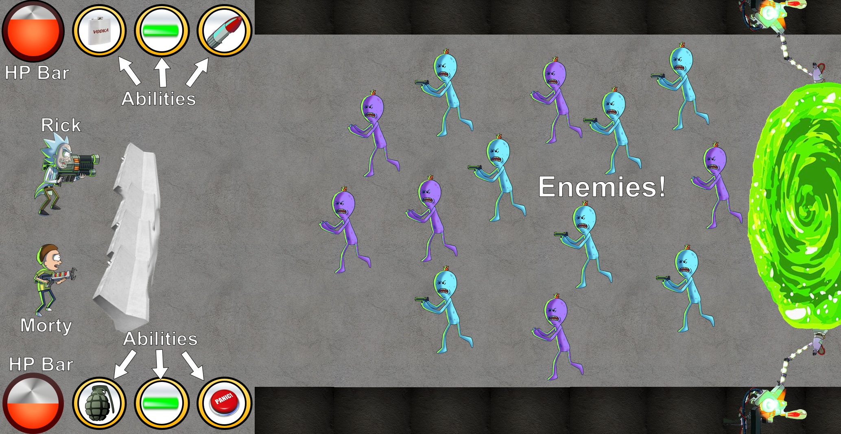

Click to shoot! Target the enemies you want to hit.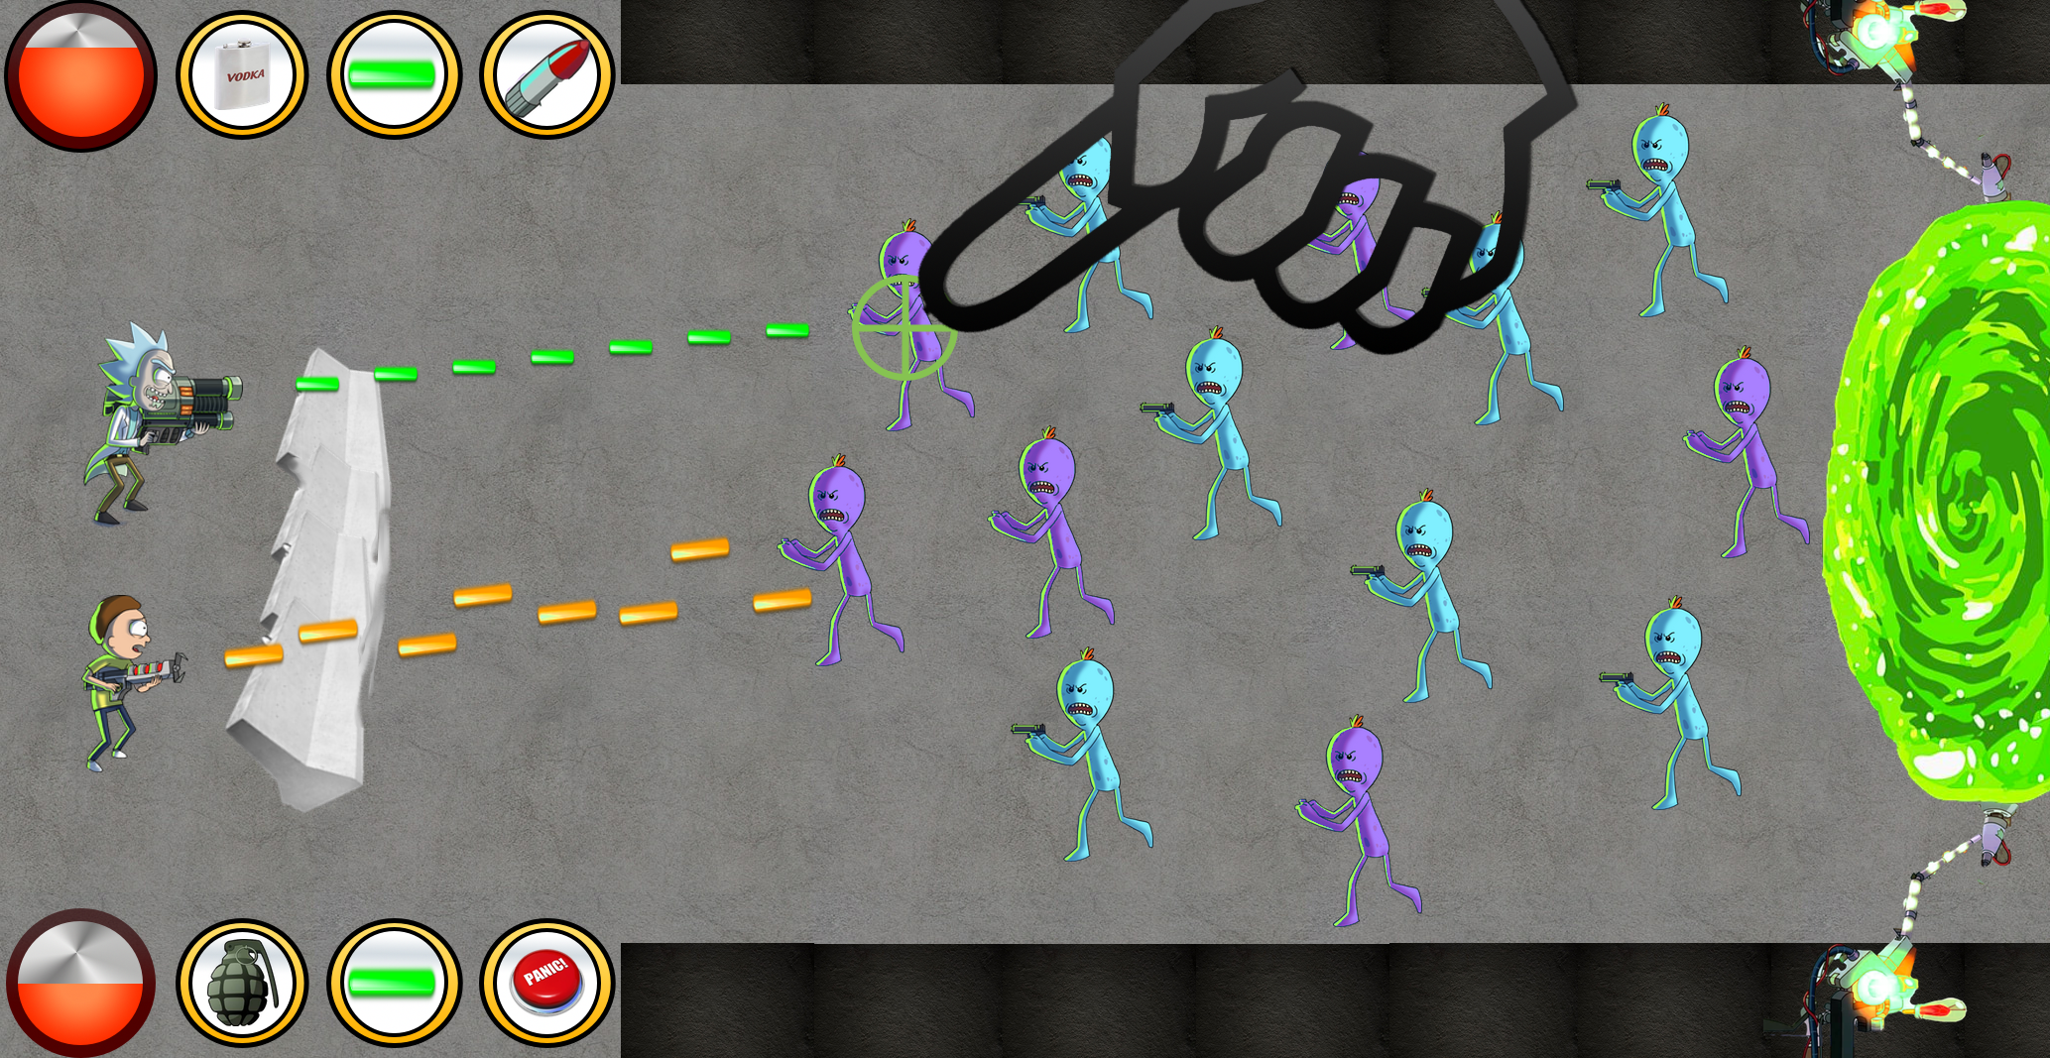

Let Autoplay Fight For You! Rick and Morty will attack targets on their own.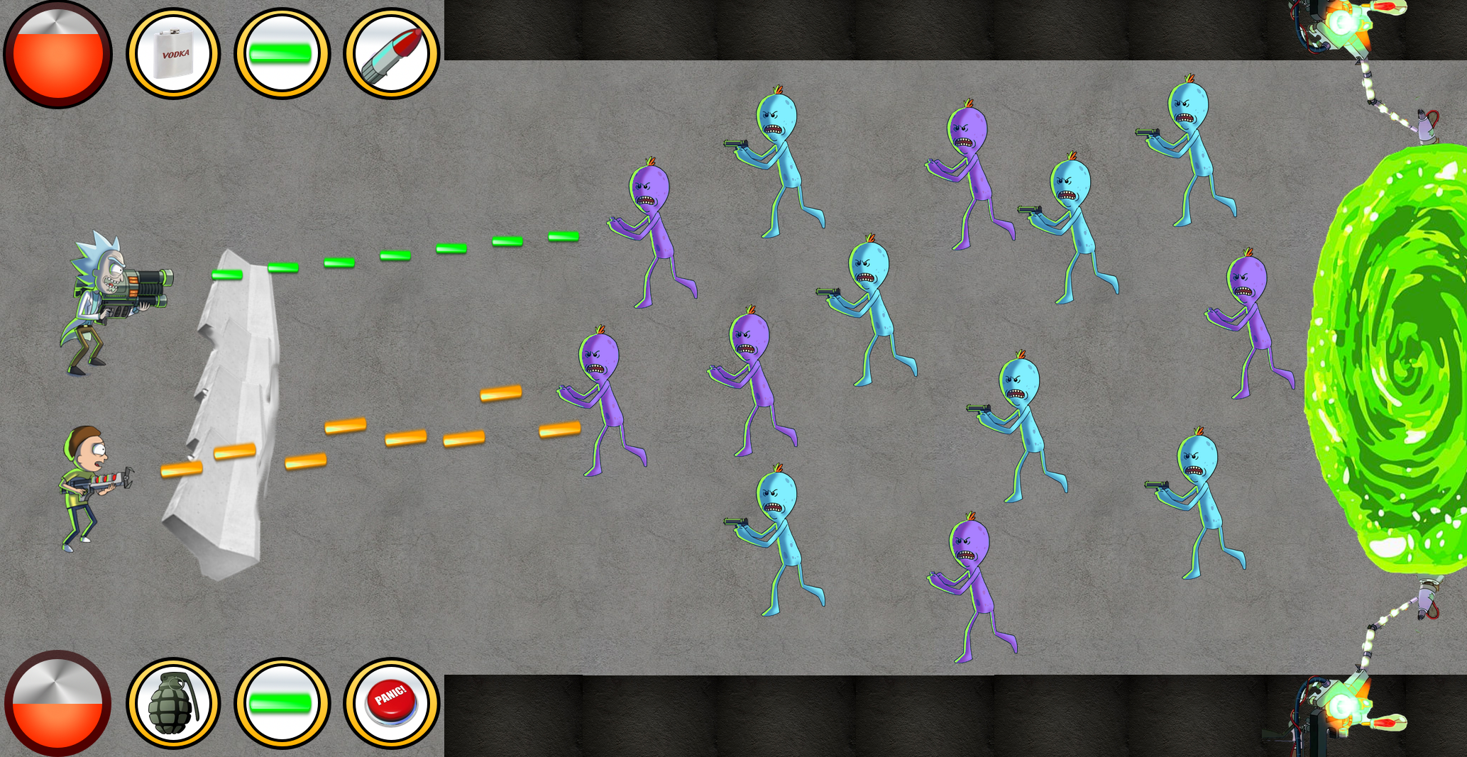

After clearing out waves of enemies collect sweet loot!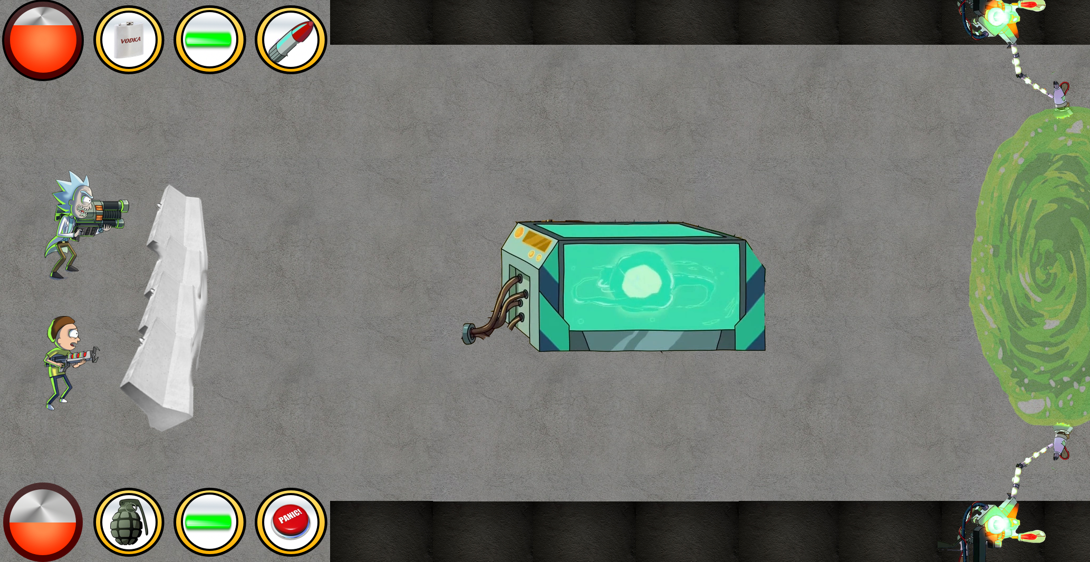

Play through hundreds of levels and find the most exciting power ups, craftable items, armor for your characters and visual upgrades for your home.

Whenever you play in a battle it costs energy, players can purchase more energy or wait for it to recharge. They can also go and fight a PVP battle instead.

# 2: COLLECTing LOOT

Collecting loot will help you make more powerful armor, better weapons and stronger units. Everything you do in the game will take collectible loot to make better. Loot collection is a very popular gameplay mechanic that can really help drive retention.

Fighting against waves of enemies gives the player instant rewards! The further you get in the campaign of the game the better rewards you get.

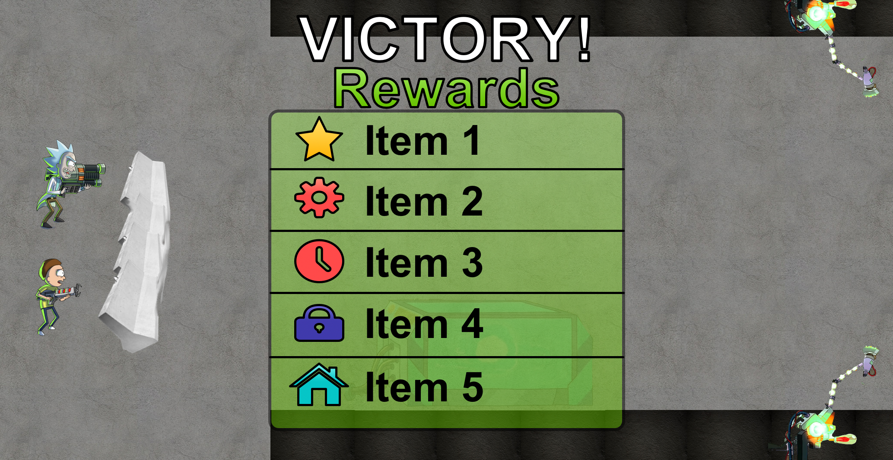

When you win a PVP battle you can collect chests! Each chest is on a timer and have more rewards inside when you collect them.

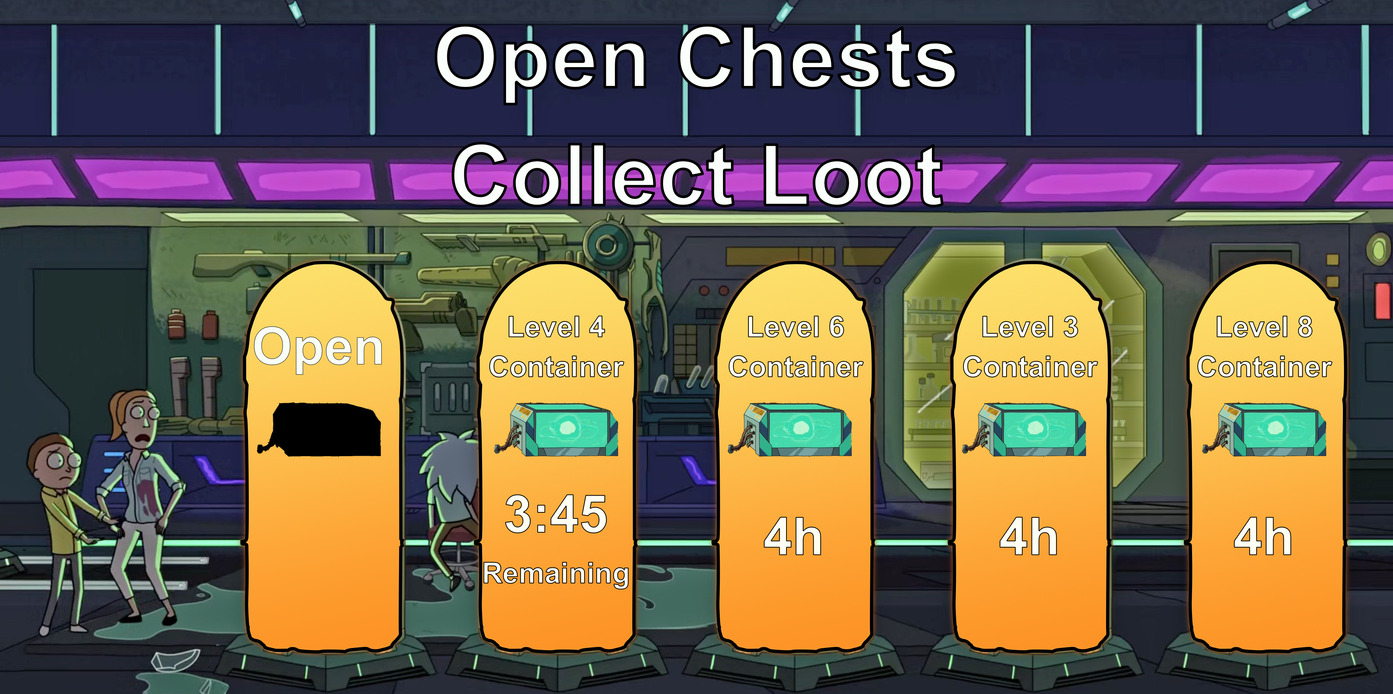

# 3: Crafting – Do I hear sci-Fi noises?

Crafting is one of the main avenues for people to level up, explore new content and invest into intricate game systems. Players will have the ability to make their own weapons from loot drops and items they find while playing the game. Each item has the potential to be unique from your friend’s items and have nearly limitless potential. Eventually, we will want players to be able to share their weapons with each other and show them off in PVP battles and in the “Council of Ricks” alliance system.

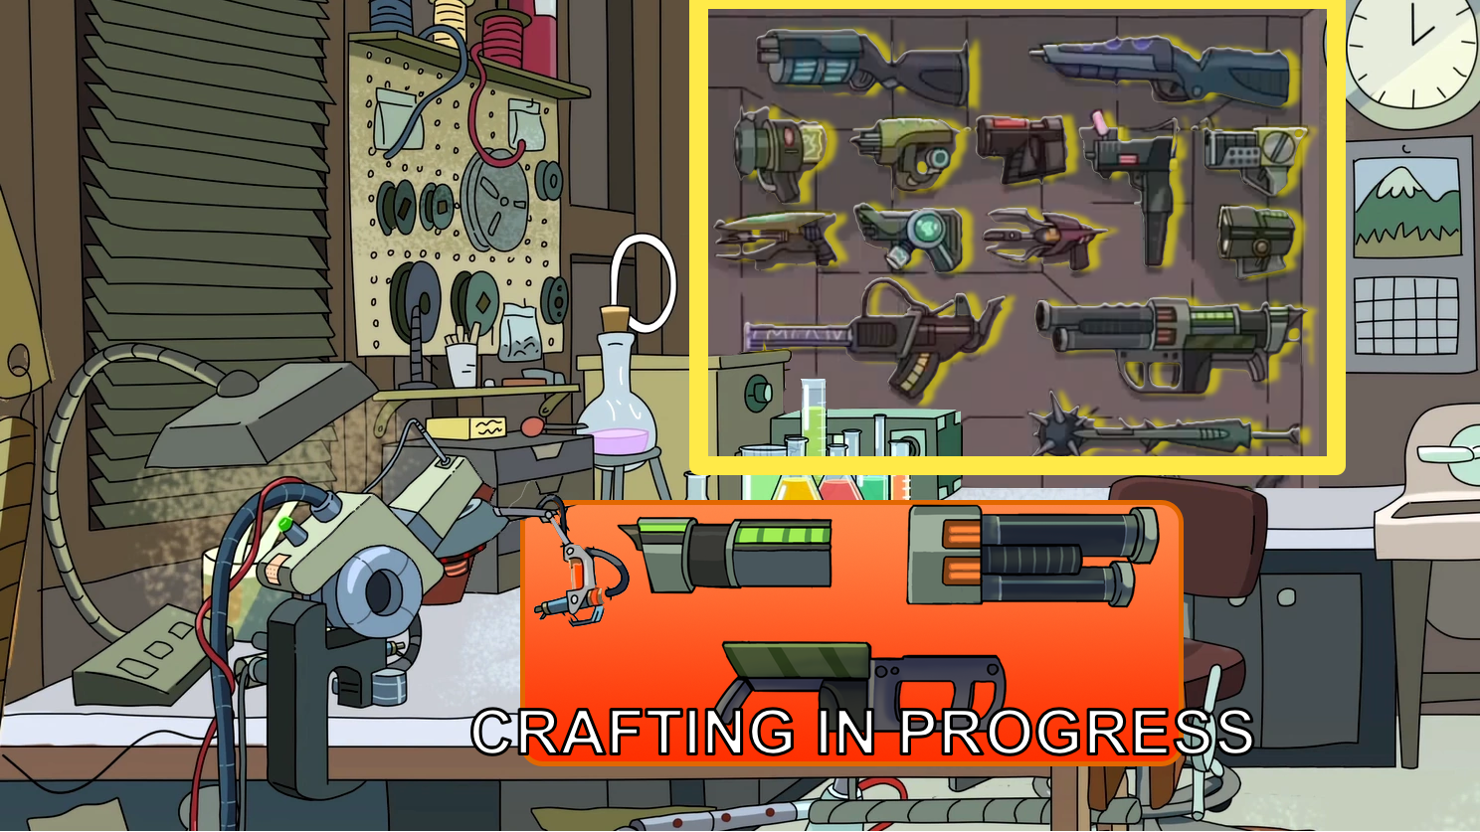

In addition to getting weapons, players will be able to craft armor, power ups and consumable items. Giving players a nearly unlimited amount of things to spend time figuring out and making.

# 4: CUSTOMIZE – SHOW ME WHAT YOU GOT!

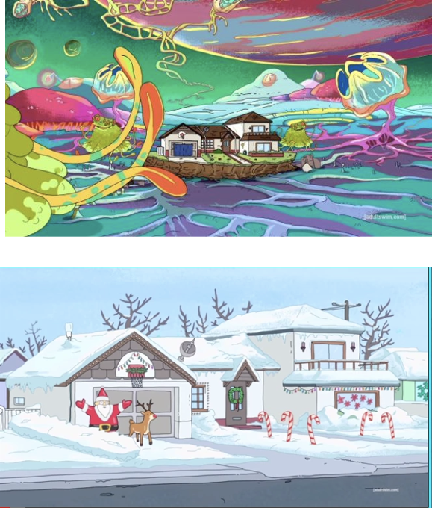Part of the exciting thing about crafting and getting near gear is showing off what you have made and what your Rick and Morty look like. Collect new armor, gear, weapons and unique ways to customize the Smith residence your Rick presides over. Every player’s Rick and Morty will get to be unique in some way after playing the game for long enough.

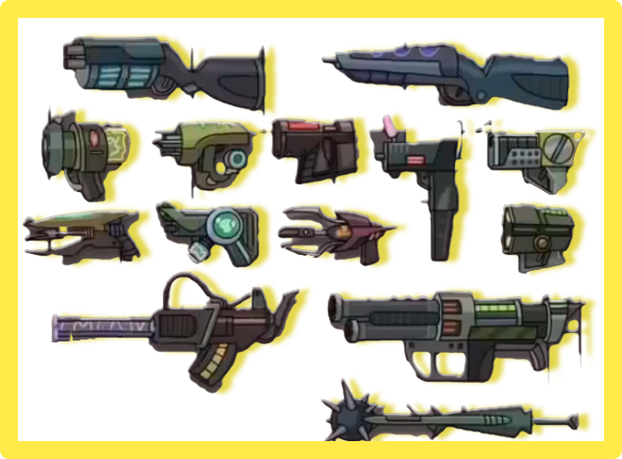 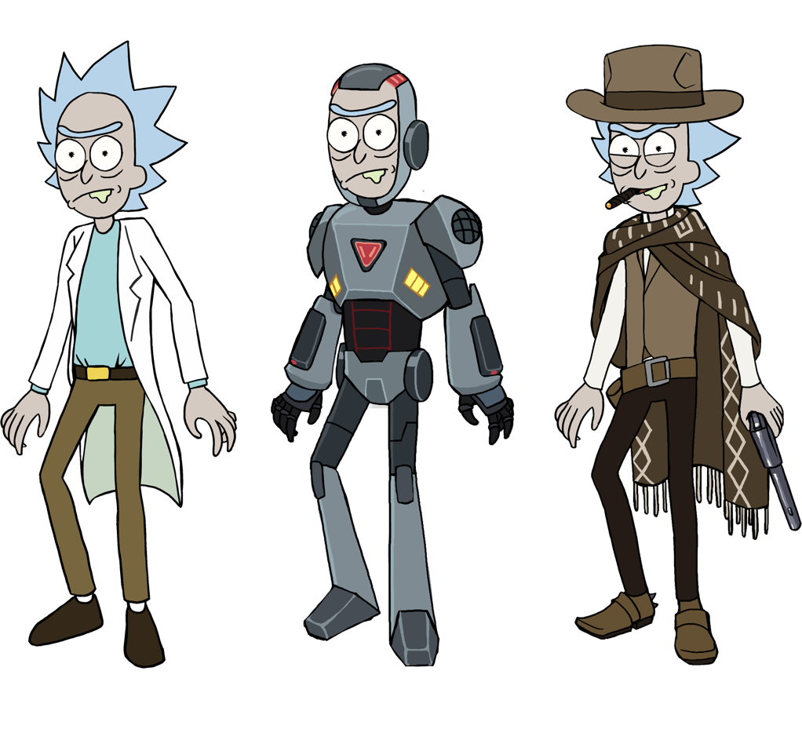

The main ways to show off your Rick are:

1. Play PVP Battles
2. Visit your Friend’s Smith Residence
3. Share your gear with your council.

# 5: PVP – FIGHTING OTHER RICKS

Fighting against other Ricks will be a part of a trophy based ladder ranking system like many popular games on the app store. By fighting other Rick’s and climbing through the ladder you will have the opportunity to be the Rickiest Rick.

The PVP gameplay involves your Rick and Morty squaring off against another Rick and Morty and sending waves of enemies at each other. The last Rick standing wins trophies and a chest if available

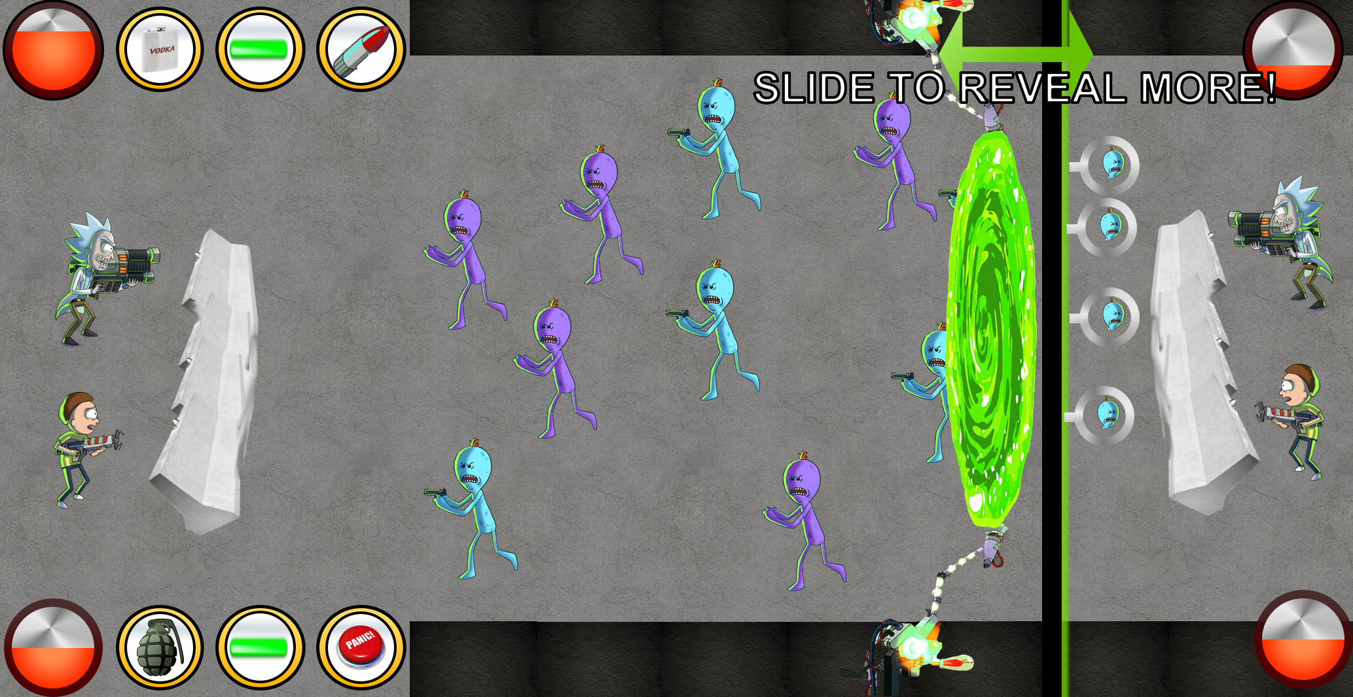

# 6: the rickiest rick – PVP LADDER

When you play other players in the PVP system you get trophies to climb up the leaderboards! Winning battles earns you trophies and losing battles causes you to lose trophies. As you progress further up the leaderboards you’ll have access to some interesting perks and better loot from your chests. The PVP system will have seasons and player’s trophy counts will be reset after each season. When a player wins a season they will forever have a chat badge, unique piece of gear or customizable item that shows off that for a season they were the Rickiest Rick.

Leaderboards and PVP ladders are a great way to keep players engaged over a long period of time and continue to explore new content to become more powerful.

(screenshot of something ladder like with Rick’s head or whatever)

# 7: COUNCIL OF RICKS – GUILD SYSTEM

Social interactions are an important part of any mobile game, bringing people together helps them stay in the game longer and makes interactions more exciting. By teaming up with other Rick’s you’ll be able to share resources and technology, discuss strategies, show off your customized equipment and play with your friends.

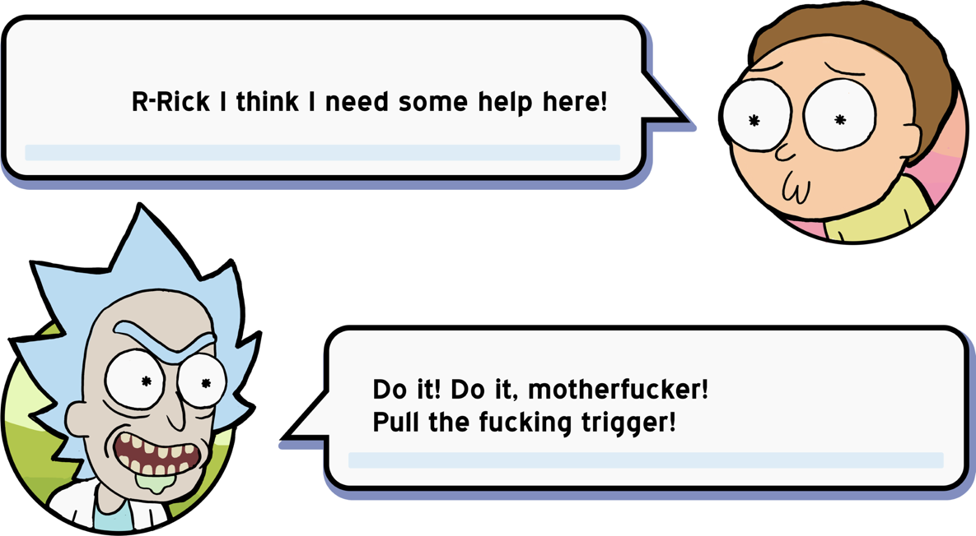

Maybe a little peer pressure as well

# 8: Monetization – GETTING SCHMEKLES

1. Crafting Sinks
   1. Instant complete crafting
   2. Sell unique crafting items
   3. Selling Power ups for crafted items
   4. Easy content expansion post release
2. Gameplay Sinks
   1. Purchasing more energy
   2. Instant revives
   3. Restocking gear
   4. Temporary battle power ups
3. PVP Sinks
   1. Getting better gear and leveling up becomes more important
   2. Speeding up the opening of special PVP chests
   3. Showing off your customization makes customizing more exciting.
4. Customization Sinks
   1. Show off to your friends
   2. Look awesome and share it on facebook

# 9: Dev requirements and risks

Team Size: 1 Product Manager, 1 Producer/Project Manager, 1 Art outsourcing specialist, 6 Programmers, 2 designers (one with UI/UX experience), 2 internal artists.

**Soft Launch**: 8 Months after having a full team

* Gameplay – Low Risk, high development and polish time
* Crafting – Technically Higher Risk, large development time, polish can be done after the game is shipped.
* 200+ Levels of enemies – Low risk, lots of design time.
* Basic global chat system – Low Risk, implemented in proprietary tech already.
* Basic sales system, verify that people are interesting in purchasing crafting and buffs. – Low risk, implemented in proprietary tech already.

**World Wide Launch**: 4 Months after soft launch

* Smith Residence and Smith Residence Customization – Low risk technically but will require a lot of design time and artwork.
* PVP Battles and Ladder System – High risk technically and from a design perspective. Need to account for more units and another player which will be tricky.
* Basic Friends List – Low risk but part of the basics of any game with social features.
* 200+ more levels – Same as above
* Improved sales and monetization loops – Should be able to improve monetization with data taken from soft launching the game.

**Major Update 1**: 2 Months after world wide launch

* Council of Rick System – Low Risk, guild systems are a known quantity.
* Improvements to trophy system – Will improve off of data from World Wide Launch
* Increase crafting supplies, enemies you can make for PVP and additional levels – Low risk but content heavy.